**Figure A**. Age distributions of patients who received one or more doses of HPV vaccine by gender, race, and ethnicity.

1. Male patients with one or more HPV Vaccine doses.
2. Black people with one or more HPV Vaccine doses.
3. Asian people with one or more HPV Vaccine doses.
4. Non-Hispanic people with one or more HPV Vaccine doses.
5. Hispanic people with one or more HPV Vaccine doses.
6. White people with one or more HPV Vaccine doses.
7. All patients with one or more HPV Vaccine doses
8. Female patients with one or more HPV Vaccine doses.

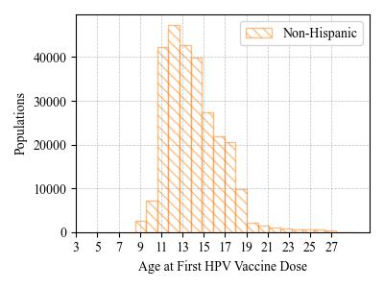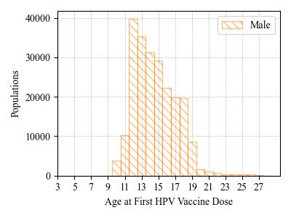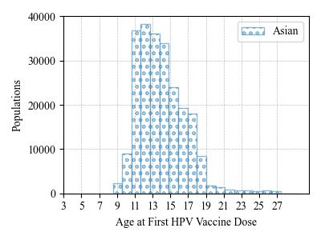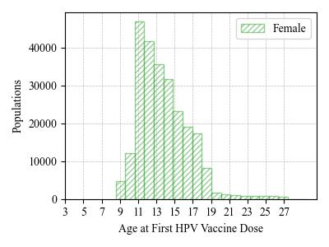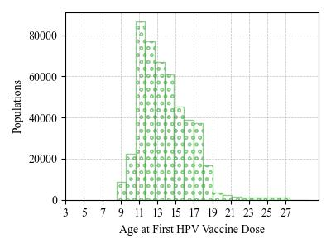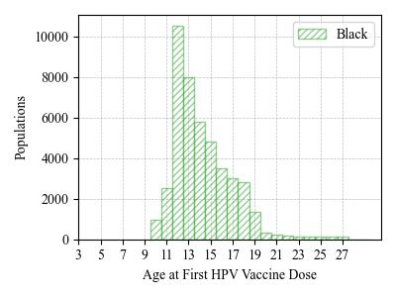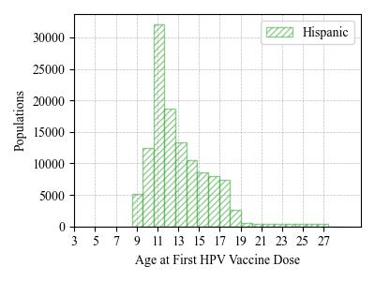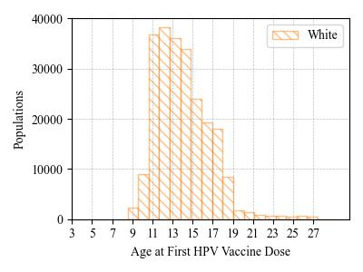

1. HPV vaccine initiation rate for LI children   
    ages 9-13 by race and ethnicity.

**Figure B**. HPV vaccine initiation rate among 9- to 13-year-old children in Nassau and Suffolk Counties, New York. The rate here was calculated by the number of children who already initialized the HPV vaccination divided by the number of children either receive the HPV vaccination or Tdap vaccination.

1. HPV vaccine initiation rate for LI children ages 9-13 by gender.
2. HPV vaccine initiation rate for Suffolk children ages 9-13 by gender.
3. HPV vaccine initiation rate for Nassau children ages 9-13 by gender.
4. HPV Vaccinated LI children ages 9-13 by Season

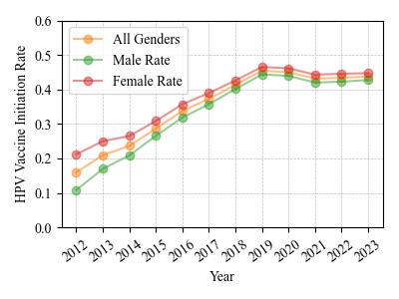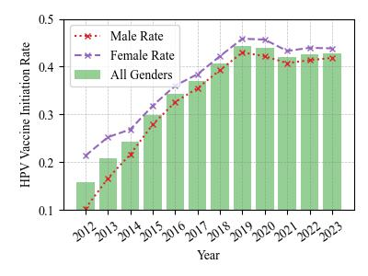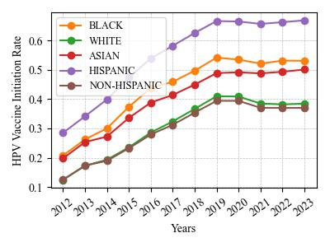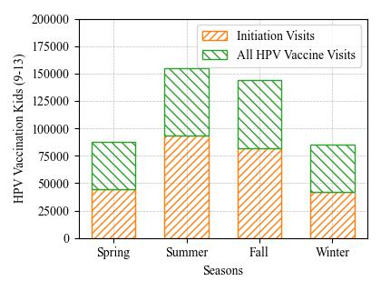

\

**Figure C.** The completeness of the HPV vaccinated individuals on the Long Island, New York State, 2012-2023. The figures are generated according to the CDC HPV vaccination guidelines.

1. The Nested Pie Chart shows the HPV Vaccination Patient Doses Schedule and Completeness Portion.

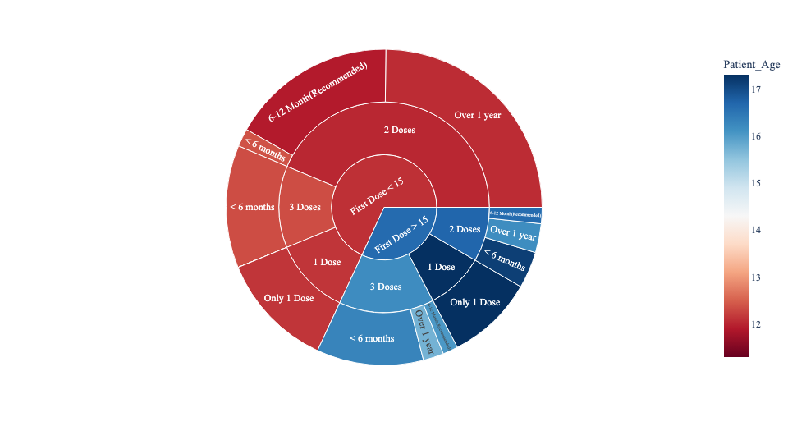

1. HPV Vaccine Series Completion by Gender
2. HPV Vaccine Series Completion by Race and Ethnicity

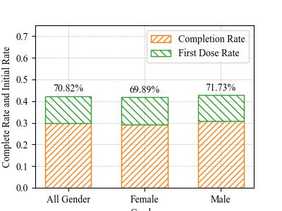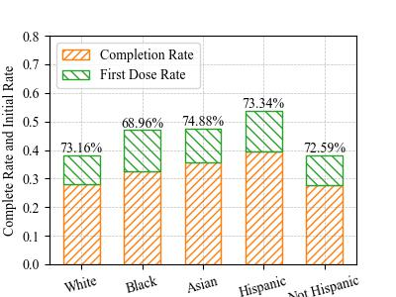

**Figure D**. Geographical maps of HPV vaccination rates on Long Island, New York (Nassau and Suffolk Counties) among children ages 9-13 by zip code. The rate was calculated by the number of children receiving one or more HPV vaccine dose divided by the number of children who received HPV, Tdap or both vaccines.

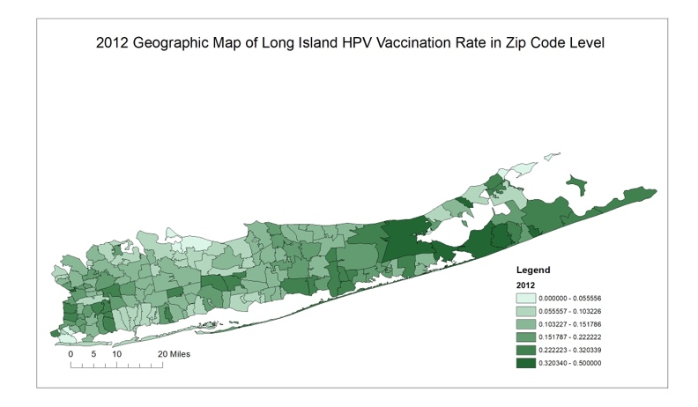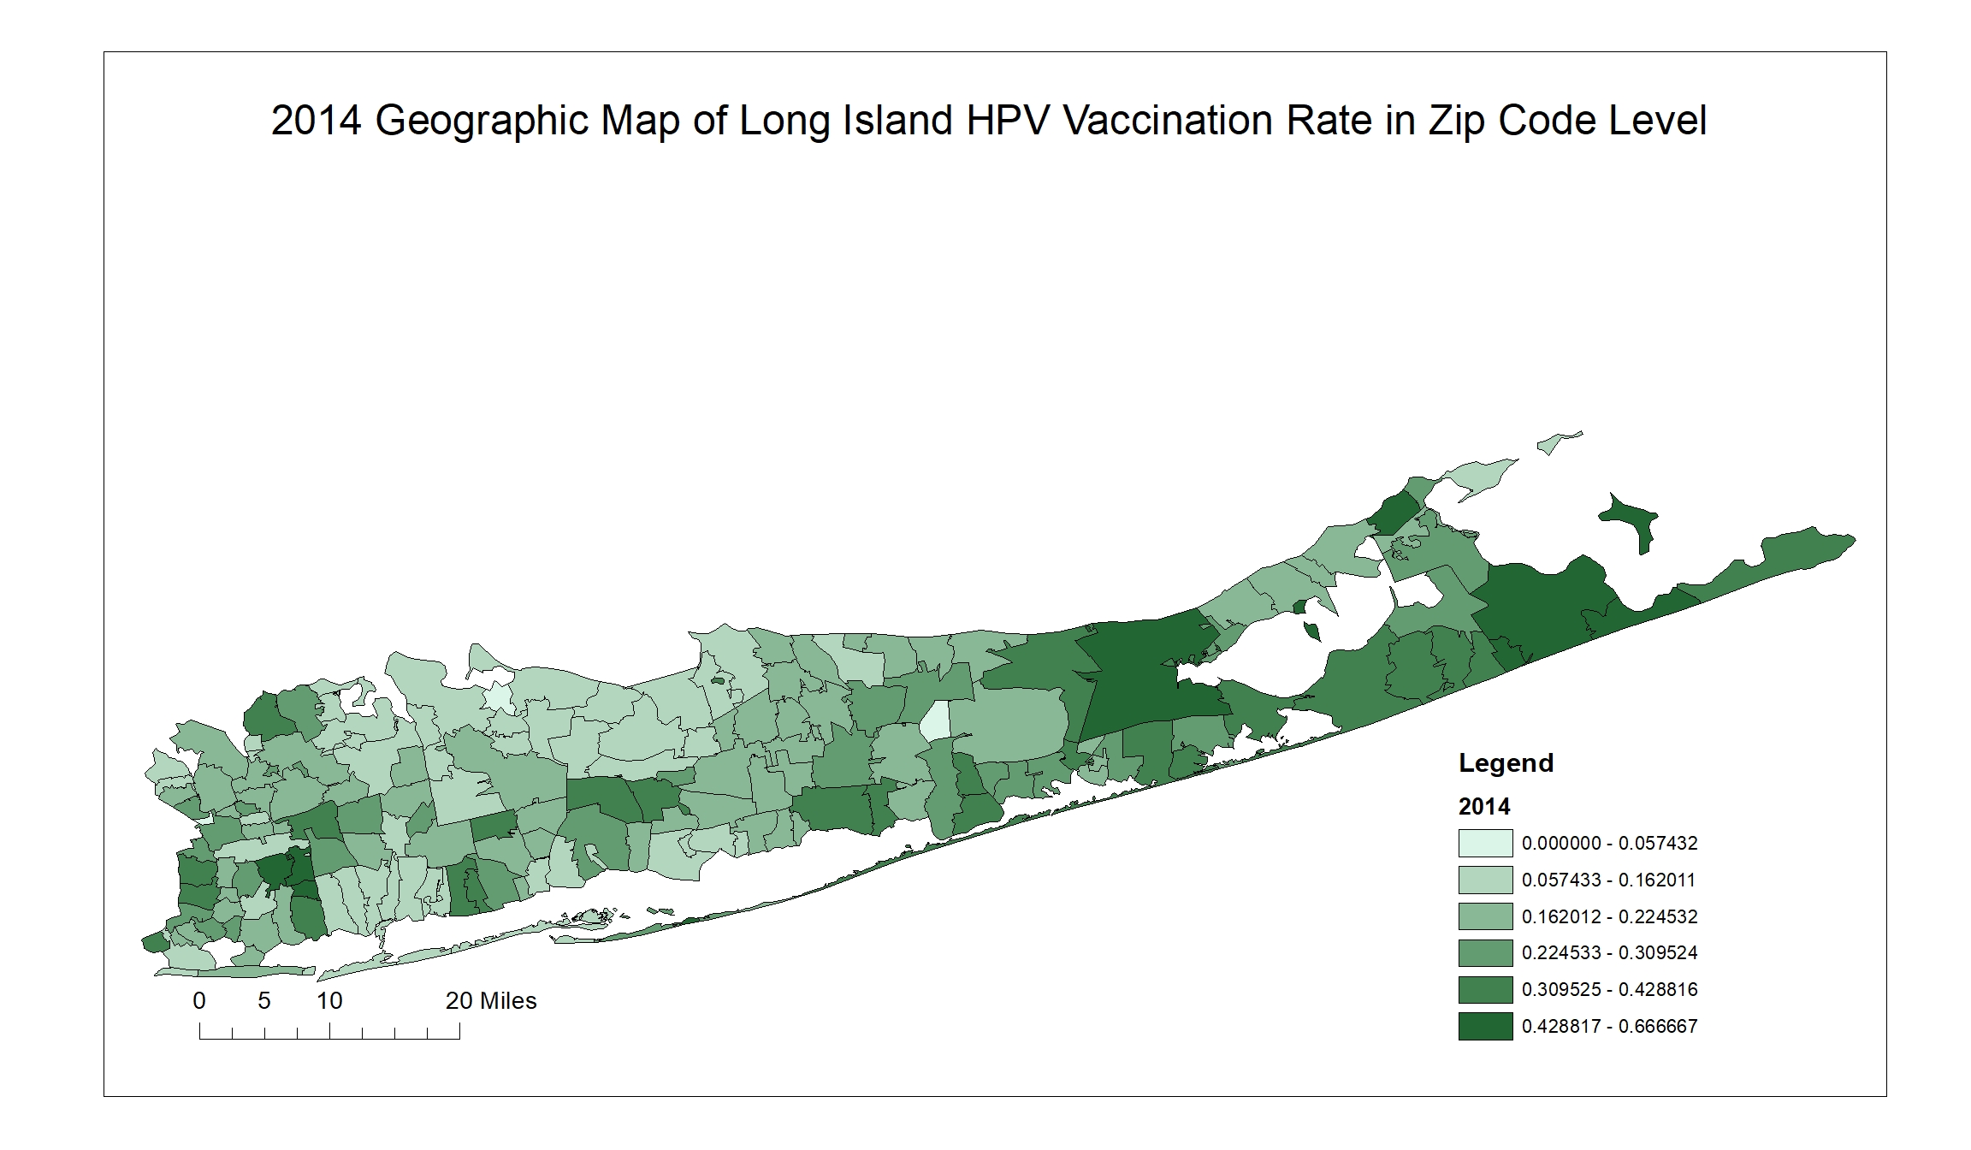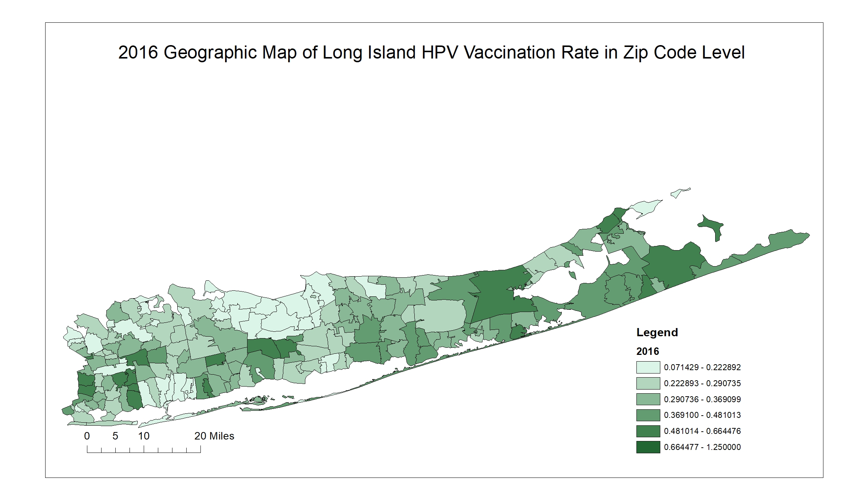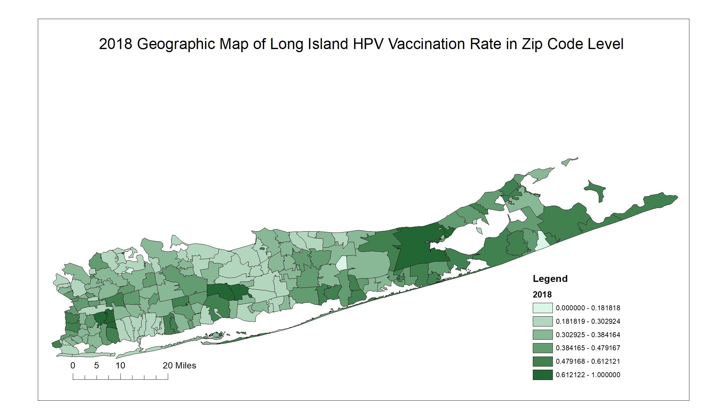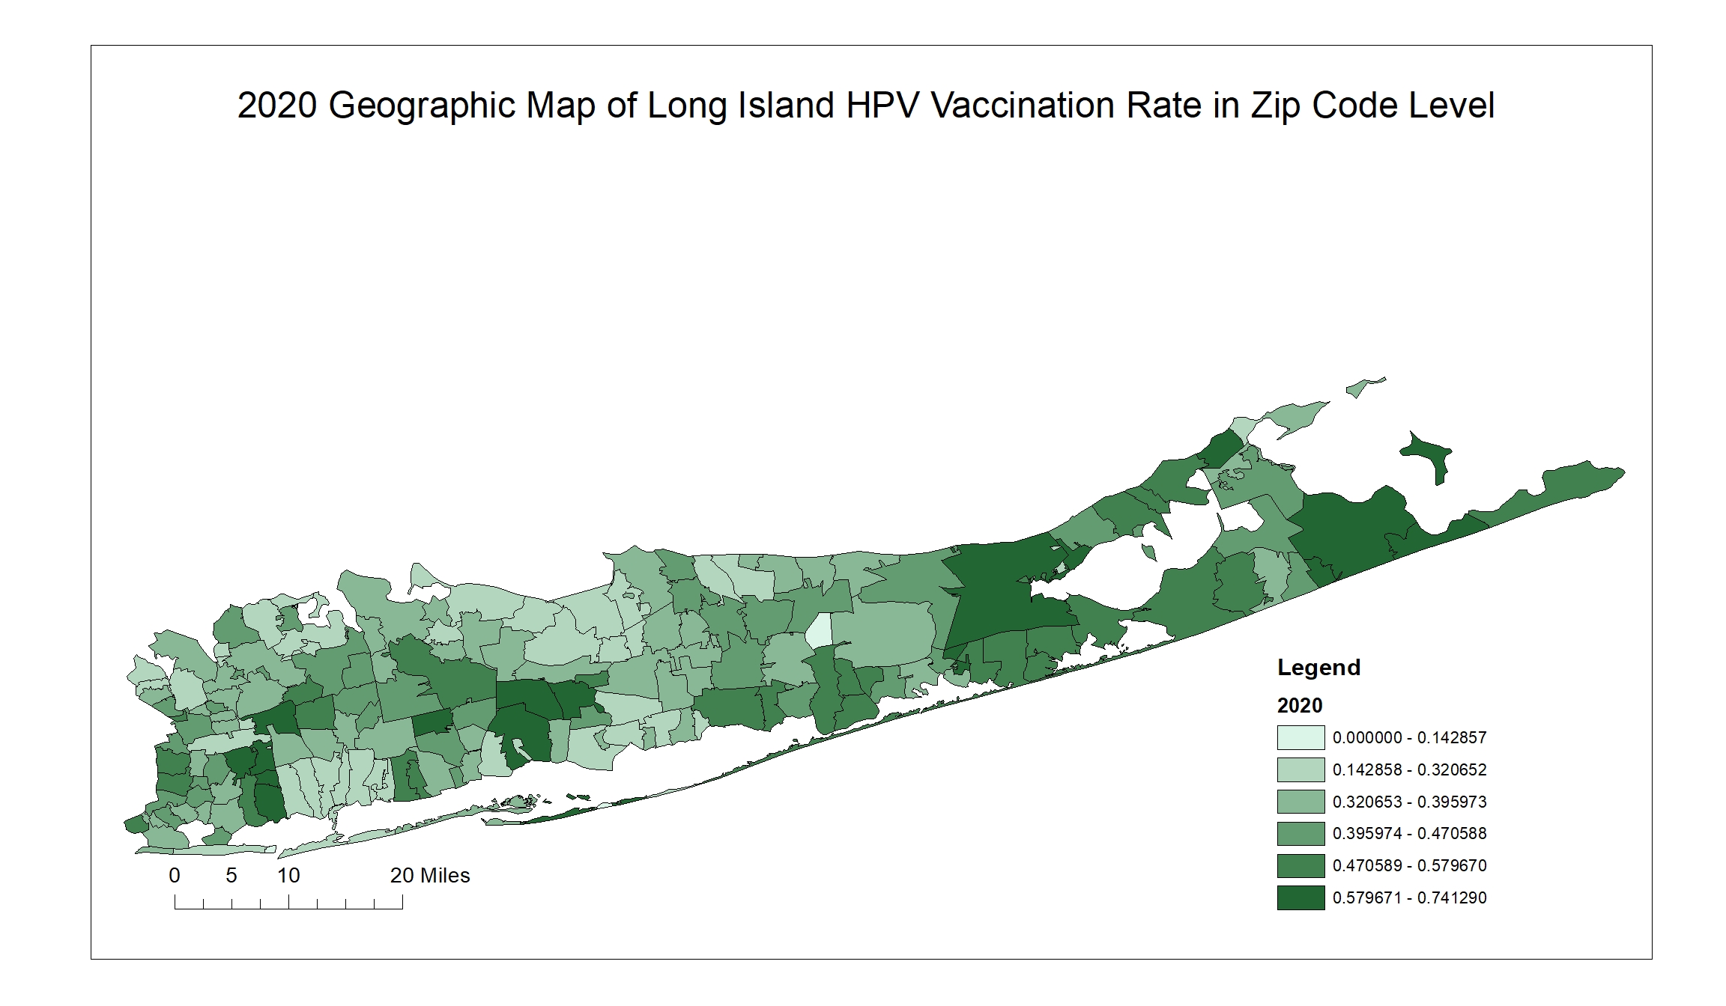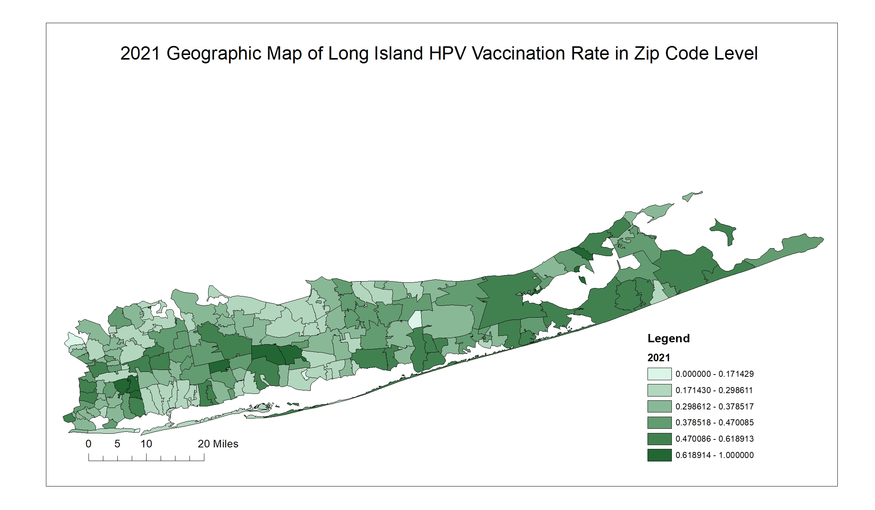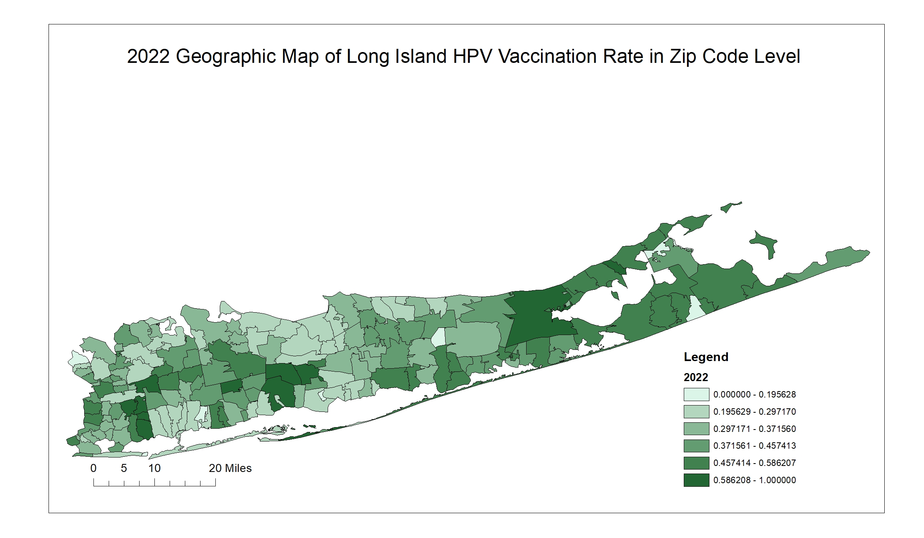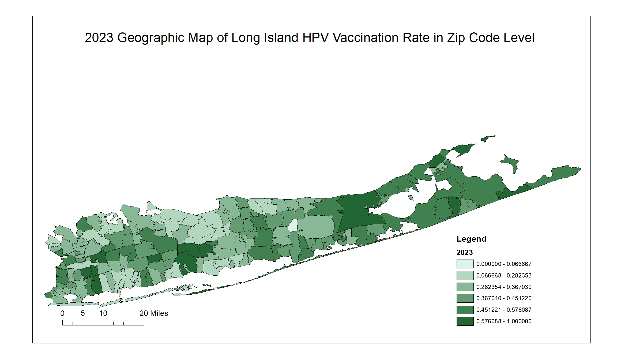

1. (2012) Geographic Map of Long Island HPV Vaccination Rate by Zip Code
2. (2016) Geographic Map of Long Island HPV Vaccination Rate by Zip Code
3. (2014) Geographic Map of Long Island HPV Vaccination Rate by Zip Code
4. (2018) Geographic Map of Long Island HPV Vaccination Rate by Zip Code
5. (2020) Geographic Map of Long Island HPV Vaccination Rate by Zip Code
6. (2021) Geographic Map of Long Island HPV Vaccination Rate by Zip Code
7. (2022) Geographic Map of Long Island HPV Vaccination Rate by Zip Code
8. (2023) Geographic Map of Long Island HPV Vaccination Rate by Zip Code

|  |  |  |  |  |  |  |  |  |  |  |  |  |  |  |  |
| --- | --- | --- | --- | --- | --- | --- | --- | --- | --- | --- | --- | --- | --- | --- | --- |
| **Table A.** Summary of Aggregation Information of HPV Vaccination Patients on the Long Island. (The patients from the entire NYSIIS database) 1 | | | | | | | | | | | | | | P value | |
|  |  | 2012 | 2013 | 2014 | 2015 | 2016 | 2017 | 2018 | 2019 | 2020 | 2021 | 2022 | 2023 | Linear | Overall |
| Gender | Male | 20574 | 38493 | 56711 | 77367 | 99946 | 120951 | 142650 | 163788 | 179135 | 193555 | 209654 | 225007 | <0.0005 | <0.0005 |
| Female | 55221 | 70823 | 86802 | 106035 | 126958 | 146873 | 166948 | 187044 | 202339 | 216664 | 232859 | 248334 | <0.0005 | <0.0005 |
| Age | 9-142 | 16458 | 23004 | 28215 | 36383 | 44374 | 49557 | 54729 | 58983 | 56735 | 52808 | 51848 | 51522 | <0.0005 | <0.0005 |
| 14-26 | 59331 | 86296 | 115183 | 146644 | 181202 | 214563 | 246876 | 277885 | 302238 | 322171 | 338127 | 348376 | <0.0005 | <0.0005 |
| >=26 | 162 | 239 | 410 | 725 | 1728 | 4148(1)4 | 8468 | 14473(3) | 23030(1) | 25799(3) | 53149(3) | 74101(6) | <0.0005 | <0.0005 |
| Race and Ethnic | White | 32635 | 49774 | 66838 | 86873 | 109218 | 130939 | 152995 | 174070 | 190051 | 203714 | 218956 | 233244 | <0.0005 | <0.0005 |
| Black | 6643 | 9529 | 12635 | 16727 | 21117 | 25031 | 28954 | 32860 | 35569 | 38436 | 41532 | 44677 | <0.0005 | <0.0005 |
| Asian | 3990 | 5803 | 7830 | 10642 | 13637 | 16675 | 20017 | 23285 | 25957 | 28451 | 31613 | 34801 | <0.0005 | <0.0005 |
| Hispanic | 14329 | 21043 | 29631 | 39846 | 51594 | 61855 | 72568 | 84262 | 92393 | 101611 | 112155 | 122192 | <0.0005 | <0.0005 |
| Non-Hispanic | 38598 | 58515 | 78026 | 101732 | 127471 | 152483 | 177657 | 201188 | 219371 | 234853 | 252642 | 269436 | <0.0005 | <0.0005 |
| Total |  | 75954 | 109540 | 143808 | 183751 | 227304 | 268268 | 310072 | 351339 | 381998 | 410773 | 443121 | 473995 | <0.0005 | <0.0005 |

1. The absolute numbers here represent the number of individuals in the specific group with one or more HPV vaccine doses.
2. Children ages 9- to 13-year-old are the targeted population studied in this paper.
3. HPV vaccination is not recommended for everyone older than age 26 years.
4. The numbers in the parentheses show the newly added patients who initiated the HPV vaccination during that year.